CASE STUDY REPORT
OPTIMIZING JOB SHOP SCHEDULING
USING DEEP REINFORCEMENT LEARNING
A Technical Report
Submitted in partial fulfillment of the requirements for the degree of
Master of Applied Artificial Intelligence for Digital Production Management
Deggendorf Institute of Technology
Campus Cham, Germany
Submitted by
Rifshu Hussain Shaik (12505018)
Ankith Ramesh Babu (22403982)
Alwin Shaji (22407660)
Sanaboyina Satya Narasimha (12503984)
Gnanasudha Patur (12501826)
15th January 2026

Table of Contents
Abstract 5
1. Introduction 6
1.1 Background and Industrial Context 6
1.2 Problem Definition and Mathematical Complexity 6
1.3 The Dynamics of Uncertainty 6
1.4 Limitations of Conventional Heuristics 7
1.5 Research Objectives and Proposed DRL Approach 7
2. Literature Review 8
2.1 Theoretical Foundations of JSSP and Computational Complexity 8
2.2 Meta-Heuristics: Bridging the Gap to Global Optimality 8
2.3 The Shift Toward Deep Reinforcement Learning (DRL) 8
2.4 Proximal Policy Optimization (PPO) and Training Stability 9
2.5 Automated Hyperparameter Tuning with Optuna 9
2.6 Summary of Academic Gaps Addressed 9
3. Methodology 10
3.1 Industrial Digital Twin Architecture 10
3.2 Event-Driven System Dynamics 11
3.2.1 Stochastic Job Arrivals 11
3.3 Heuristic and Meta-Heuristic Methods 11
3.3.1 Baseline Priority Dispatching Rules (PDRs) 11
3.3.2 Ant Colony Optimization (ACO) 12
3.3.3 Particle Swarm Optimization (PSO) 12
3.4 Deep Reinforcement Learning: Proximal Policy Optimization (PPO) 12
4. Results and Discussion 13
4.1 Experiment 1: 200 Jobs with 20 Machines 13
4.2 Experiment 2: 100 Jobs with 15 Machines 14
4.3 Experiment 3: 50 Jobs with 7 Machines 15
4.4 Discussions 16
5. Conclusion and Future Work 16
5.1 Conclusion 16
5.2 Future Work 17
References 18

List of Figures
Figure 1: Simulation + Algorithm Flowchart 10
Figure 2: PPO Framework 12
Figure 3: Average Tardiness and Jobs Finished with 20 Machines 13
Figure 4: Average Tardiness and Jobs Completed with 15 Machines 14
Figure 5: Average Tardiness and Jobs Completed with 7 Machines 15

List of Abbreviations
Abbreviation | Expanded Form
ACO | Ant Colony Optimization
DJSSP | Dynamic Job Shop Scheduling Problem
DQN | Deep Q-Network
DRL | Deep Reinforcement Learning
FIFO | First-In-First-Out
MARL | Multi-Agent Reinforcement Learning
MDP | Markov Decision Process
MILP | Mixed-Integer Linear Programming
MORL | Multi-Objective Reinforcement Learning
MTTF | Mean Time To Failure
MTTR | Mean Time To Repair
PDR | Priority Dispatching Rule
PPO | Proximal Policy Optimization
PSO | Particle Swarm Optimization
RL | Reinforcement Learning

Abstract
The Job Shop Scheduling Problem (JSSP) represents a fundamental challenge in industrial operations research, characterized by its NP-hard combinatorial complexity and high sensitivity to real-time disturbances. In modern manufacturing systems, the efficiency of production scheduling directly dictates operational throughput, resource utilization, and delivery reliability. While traditional Priority Dispatching Rules (PDRs), such as First-In-First-Out (FIFO) and Shortest Processing Time (SPT), remain industrially prevalent due to their low computational cost, they rely on local decision logic that lacks the adaptability required for stochastic environments.
This report investigates the transition from static heuristics to adaptive, data-driven decision-making by implementing a Deep Reinforcement Learning (DRL) framework. The scheduling task is formulated as a Markov Decision Process (MDP), where a learning agent interacts with a high-fidelity discrete-event simulation built using SimPy and Gymnasium. This environment explicitly models dynamic industrial variables, including stochastic job arrivals and machine unreliability (MTTF/MTTR).
To establish an academic and empirical benchmark, this study conducts a comparative analysis between baseline heuristics, meta-heuristics—specifically Ant Colony Optimization (ACO) and Particle Swarm Optimization (PSO)—and the Proximal Policy Optimization (PPO) algorithm. The PPO agent is further refined through Optuna-based Bayesian optimization, which systematically tunes hyperparameters across 100 trials to ensure training stability and policy convergence.
Performance is evaluated using key industrial metrics: Makespan, Total Tardiness, and Machine Utilization. The experimental results demonstrate that the DRL-based approach significantly outperforms traditional methods in dynamic scenarios, exhibiting a superior capacity to mitigate bottleneck cascades and adapt to machine downtime. This research confirms that DRL provides a robust, scalable foundation for autonomous production management in the context of Industry 4.0 and intelligent manufacturing systems.

1. Introduction

1.1 Background and Industrial Context
In the contemporary landscape of Industry 4.0, manufacturing enterprises are under escalating pressure to enhance operational efficiency while maintaining the flexibility to handle high-mix, low-volume production cycles. At the heart of this industrial challenge lies the Job Shop Scheduling Problem (JSSP). Efficient scheduling is not merely a logistical necessity but a critical determinant of an enterprise's ability to meet delivery deadlines, minimize work-in-process (WIP) inventory, and maximize resource utilization [1]. As production systems become increasingly interconnected and data-driven, the transition from static, manual scheduling to autonomous, intelligent decision-making systems has become an imperative for digital production management [2].

1.2 Problem Definition and Mathematical Complexity
The JSSP is a foundational combinatorial optimization problem where a set of $n$ jobs must be processed on a set of $m$ machines. Each job follows a unique technological route—a predefined sequence of operations that must be executed on specific machines for a given duration. The problem is mathematically classified as NP-hard, as the search space of potential permutations expands factorially with the number of jobs and machines [3].
The primary constraints governing the environment include:
- Resource Capacity: Each machine can process only one operation at any given time.
- Operation Precedence: The k^{th} operation of a job cannot commence until the (k-1) ^{th} operation is fully completed.
- Non-Pre-emption: Once an operation begins, it must continue to completion without interruption.

1.3 The Dynamics of Uncertainty
While the classical JSSP assumes a static environment where all parameters are known a priori, real-world manufacturing is inherently stochastic. This research specifically addresses the Dynamic Job Shop Scheduling Problem (DJSSP) by incorporating three critical variables of uncertainty:
- Stochastic Job Arrivals: Jobs enter the system at random intervals, modeled via a Poisson process, preventing the scheduler from having complete future visibility.
- Machine Reliability: Industrial equipment is subject to failure. This project integrates a reliability model using Mean Time To Failure (MTTF) and Mean Time To Repair (MTTR), requiring the system to perform real-time rescheduling upon equipment breakdown [4].
- Variable Priorities and Due Dates: Jobs are assigned varying priority levels and strict deadlines. Tardiness—the delay beyond a job's due date—incurs significant economic penalties and diminishes customer service levels [5].

1.4 Limitations of Conventional Heuristics
Historically, shop floors have relied on Priority Dispatching Rules (PDRs) such as First-In-First-Out (FIFO) or Shortest Processing Time (SPT). Although these heuristics are computationally inexpensive and easy to implement, they are "myopic" in nature; they make local decisions without considering the global state of the factory or the long-term implications of current actions [6]. Furthermore, meta-heuristic approaches like Ant Colony Optimization (ACO) and Particle Swarm Optimization (PSO), while effective at finding near-optimal global solutions, often struggle with the computational overhead required for instantaneous re-optimization in the face of sudden disruptions like machine failures.

1.5 Research Objectives and Proposed DRL Approach
The objective of this project is to evaluate the efficacy of Deep Reinforcement Learning (DRL) as a robust alternative to traditional methods. By framing the scheduling process as a Markov Decision Process (MDP), a DRL agent can be trained to perceive the complex state of the shop floor—including machine health, queue lengths, and job slack—to select optimal scheduling actions in real-time [7].
Specifically, this report details:
- The development of a SimPy and Gymnasium compatible simulation environment for DJSSP.
- The implementation of a Proximal Policy Optimization (PPO) agent refined through Optuna-based hyperparameter tuning.
- A statistical performance comparison against ACO and PSO meta-heuristics to validate the agent's resilience and efficiency in dynamic manufacturing scenarios.

2. Literature Review

2.1 Theoretical Foundations of JSSP and Computational Complexity
The Job Shop Scheduling Problem (JSSP) has remained a focal point of operations research since the mid-20th century. Mathematically, it is defined by a set of $n$ jobs to be processed on $m$ machines, creating (n!)^m possible sequencing permutations [8]. Due to this combinatorial explosion, JSSP is classified as NP-hard, meaning that for large-scale industrial applications, exact mathematical methods like Mixed-Integer Linear Programming (MILP) become computationally prohibitive. Early research focused on Priority Dispatching Rules (PDRs), such as First-In-First-Out (FIFO) and Shortest Processing Time (SPT). While these rules are still industrially relevant due to their "zero-calculation" nature, Panwalkar and Iskander (1977) noted that no single rule performs optimally across all factory configurations, particularly when performance metrics involve complex trade-offs between makespan and tardiness [9].

2.2 Meta-Heuristics: Bridging the Gap to Global Optimality
To overcome the local-optimality trap of PDRs, the academic community shifted toward meta-heuristics. Two prominent algorithms used in this project are Ant Colony Optimization (ACO) and Particle Swarm Optimization (PSO).
- Ant Colony Optimization: Inspired by the foraging behavior of ants, ACO utilizes digital "pheromones" to mark high-performing paths (schedules). Dorigo and Stützle (2004) demonstrated that ACO is particularly effective at identifying bottleneck machines and balancing workloads across the shop floor [10].
- Particle Swarm Optimization: PSO models potential solutions as particles moving through a multi-dimensional search space. In the context of JSSP, PSO is frequently used to optimize the weights of composite dispatching rules, allowing for a more nuanced prioritization of jobs based on remaining processing time and due-date proximity [11].

2.3 The Shift Toward Deep Reinforcement Learning (DRL)
The emergence of Industry 4.0 has introduced the need for "Dynamic" JSSP solutions. Static meta-heuristics require significant computational time to re-converge whenever a disruption occurs, such as a machine breakdown or a rush-order arrival. This limitation has paved the way for Deep Reinforcement Learning (DRL).
Unlike traditional algorithms, DRL treats scheduling as a sequential decision-making process modeled by a Markov Decision Process (MDP). In this framework, the environment (the shop floor) provides a state vector S_t, the agent (the scheduler) selects an action A_t (which job to process next), and the environment returns a reward R_{t+1} and a new state S_{t+1} [8]. Sutton and Barto (2018) emphasize that the primary advantage of RL is its ability to learn "off-line" and execute "on-line," allowing for sub-second decision-making once the model is trained.

2.4 Proximal Policy Optimization (PPO) and Training Stability
Within the DRL landscape, several algorithms have been applied to JSSP, most notably Deep Q-Networks (DQN) and Policy Gradient methods. However, DQN often suffers from instability when dealing with the high-dimensional, continuous state spaces found in complex manufacturing environments. Schulman et al. (2017) introduced Proximal Policy Optimization (PPO) as a solution to this instability [12].
PPO utilizes an "Actor-Critic" architecture where the Actor proposes an action and the Critic evaluates it. By employing a clipped surrogate objective function, PPO ensures that the policy update does not deviate too drastically from the previous iteration. Recent comparative studies, such as those by Wang et al. (2024), have validated that PPO exhibits superior convergence rates and higher robustness compared to DQN in scheduling scenarios where machine failures are frequent [13].

2.5 Automated Hyperparameter Tuning with Optuna
A recurring critique of DRL in literature is its sensitivity to hyperparameters. The performance of a PPO agent can vary significantly based on the learning rate, the discount factor (gamma), and the entropy coefficient. To address this, current state-of-the-art research increasingly utilizes Bayesian Optimization. The Optuna framework represents a paradigm shift in this area, utilizing a Tree-structured Parzen Estimator (TPE) to systematically prune underperforming trials and navigate the hyperparameter search space more efficiently than traditional grid searches [14].

2.6 Summary of Academic Gaps Addressed
The literature indicates that while DRL is powerful, many studies focus on static benchmarks (like the Taillard or Lawrence instances). This project addresses a critical gap by evaluating DRL against ACO and PSO in a stochastic environment that explicitly incorporates:
- Stochastic Job Arrivals: Using a Poisson distribution to simulate real-world shop-floor unpredictability.
- Machine Reliability Models: Implementing MTTF and MTTR distributions to test the resilience of the learned policy [15].
By integrating PPO with Optuna-based tuning and benchmarking it against sophisticated meta-heuristics, this research contributes to the validation of DRL as a viable, resilient alternative for autonomous production management.

3. Methodology
This study develops and evaluates a decision-support framework for real-time job shop scheduling in a modern manufacturing environment. The approach reflects the characteristics of real industrial shop floors, where job arrivals, machine breakdowns, and operational variability require continuous, event-driven scheduling decisions rather than static offline planning. This methodological design follows established principles in dynamic manufacturing scheduling research [16], [18], [20].
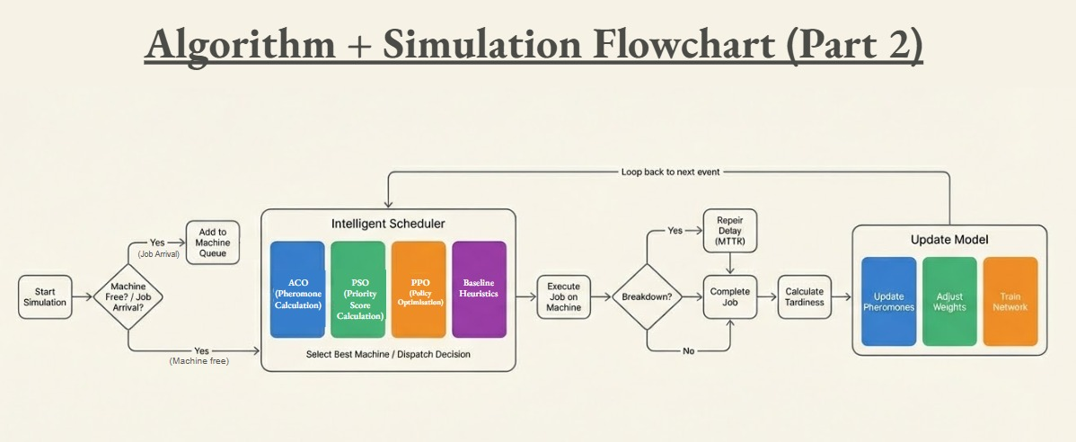
Figure 1: Simulation + Algorithm Flowchart

3.1 Industrial Digital Twin Architecture
A high-fidelity discrete-event digital twin of a 20-machine job shop was developed using SimPy Digital twins, and simulation-based evaluation environments are widely used in real industrial scheduling research to analyze online control strategies under realistic disturbances [18], [20].
Each job consists of:
- A sequence of 3–7 operations, each requiring a specific machine
- Processing times sampled from realistic machining distributions
- A due date computed from the total required processing time and slack
- A priority level used by advanced dispatching heuristics
This design mirrors real-world make-to-order production systems where job characteristics vary significantly [17], [19].
State observations include:
- Machine availability or breakdown status
- Queue lengths at each machine
- Due-date proximity (slack)
- Processing time of upcoming operations
This aligns with the typical information available to manufacturing execution systems (MES) in real time [16], [18].

3.2 Event-Driven System Dynamics
The factory model operates under asynchronous, event-driven dynamics rather than fixed time steps, consistent with real-time scheduling practice [16], [20].

3.2.1 Stochastic Job Arrivals
Jobs arrive according to a Poisson arrival process, representing unpredictable customer demand and shop-floor order releases. Dynamic arrivals are a core feature of real-time scheduling environments [16], [20], [21].

3.2.2 Machine Reliability Modeling
Machine failures follow exponential distributions defined by Mean Time To Failure (MTTF) and Mean Time To Repair (MTTR). When a machine fails:
- The job currently being processed is preempted
- Remaining processing time is preserved
- The job returns to the queue and resumes after repair
This follows typical industrial behavior for unexpected breakdowns, as documented in real-time rescheduling literature [22], [18].
The combination of dynamic arrivals and machine breakdowns transforms the classical JSSP into a Dynamic Job Shop Scheduling Problem (DJSSP), where continuous online rescheduling is necessary.

3.3 Classical and Meta-Heuristic Scheduling Approaches
To establish rigorous industrial benchmarks, the system evaluates multiple scheduling families used in practice—from simple dispatching heuristics to global optimization algorithms.

3.3.1 Baseline Priority Dispatching Rules (PDRs)
Dispatching rules are the most commonly applied real-time solution in industry due to computational simplicity and explainability [19], [19].
Two foundational PDRs are used:
- FIFO (First-In-First-Out): Orders are processed in arrival order.
A widely accepted baseline rule in manufacturing control.
- SPT (Shortest Processing Time): Prioritizes operations with minimal processing time.
Known to reduce average flow time but may increase tardiness for complex jobs [19], [21].
Both are implemented as event-driven SimPy processes

3.3.2 Ant Colony Optimization (ACO)
ACO is used as a global stochastic optimization method, frequently applied to shop-floor scheduling where local job dispatching interacts with global machine-level decisions.
In this work:
- Pheromone levels represent long-term desirability of selecting a specific machine under certain system states
- Heuristic desirability incorporates processing time and due-date slack
- Ants execute full production episodes to evaluate sequence quality
ACO for scheduling has been applied successfully in dynamic manufacturing and is supported by extensive research [19], [20].
Implementation is based on the custom ACO manager

3.3.3 Particle Swarm Optimization (PSO)
PSO is utilized as a parameter optimization tool rather than a direct sequencer. It mimics the social behaviour of bird flocking to explore a multi-dimensional search space.
- Weight Optimization: Each "particle" represents a vector of weights (W_1, W_2, W_3) assigned to different job attributes (e.g., processing time, due date, priority).
- Composite Priority Score: The particles move through the search space to find the optimal balance of these weights that minimizes global tardiness across simulation trials.

3.4 Deep Reinforcement Learning: Proximal Policy Optimization (PPO)
The core of the methodology is the implementation of the PPO algorithm. PPO is an Actor-Critic framework chosen for its superior training stability in high-dimensional state spaces.
- Actor-Critic Network: The Actor proposes scheduling actions while the Critic evaluates the "value" of the resulting state.
- Reward Engineering: A "Dense Reward" function provides the agent with immediate feedback. It penalizes machine idleness when jobs are waiting, applies exponential penalties for job tardiness, and rewards high machine utilization.
- Optuna Integration: To ensure the PPO agent's efficacy, Optuna is used to perform Bayesian optimization over N trials, systematically tuning hyperparameters such as the learning rate, discount factor (gamma), and batch size.
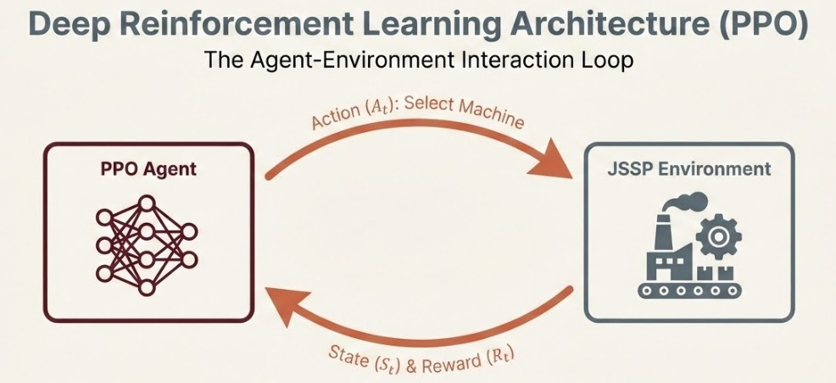Figure 2: PPO Framework

4. Results and Discussion
This section details the quantitative performance of the implemented scheduling algorithms—Baseline Heuristics (FIFO, SPT) and Meta-heuristics (ACO, PSO)—across three distinct experimental configurations. These experiments were engineered to evaluate system robustness under varying degrees of resource constraint and operational pressure.

4.1 Experiment 1: 200 Jobs with 20 Machines
The first experiment established a baseline using a standard shop floor configuration with 20 machines and a high job arrival rate (lambda approx. 10.0). The objective was to complete 200 jobs within a maximum simulation time of 2000 units. Under these conditions, the limitations of the First-In-First-Out (FIFO) rule were immediately evident; it achieved the lowest throughput, completing only 107 out of 200 jobs, and incurred a massive average tardiness of over 120,875. This poor performance is attributed to the FIFO logic, which processes jobs strictly by arrival time, allowing long-duration tasks to block critical resources regardless of downstream bottlenecks.
In contrast as shown in Figure 3, the Shortest Processing Time (SPT) heuristic significantly improved throughput, finishing 169 jobs and reducing average tardiness to approximately 98,120. This validates the SPT mechanism of prioritizing quick tasks to reduce queue lengths. However, the Particle Swarm Optimization (PSO) algorithm emerged as the superior performer. It not only achieved the highest throughput of 172 jobs but also optimized the schedule to lower the average tardiness to 69,288—a reduction of nearly 29% compared to SPT. By tuning the weights for processing time, slack, and priority, PSO successfully balanced machine efficiency with order urgency. Ant Colony Optimization (ACO) offered a middle ground, finishing 157 jobs with a tardiness of roughly 94,130, improving upon SPT’s tardiness but lagging slightly in total volume.
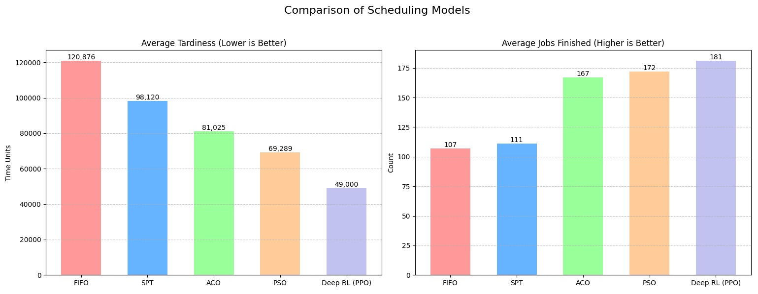
Figure 3: Average Tardiness and Jobs Finished with 20 Machines

4.2 Experiment 2: 100 Jobs with 15 Machines
The second experiment introduced significant resource contention by reducing the available resources to 15 machines while maintaining a medium arrival rate (lambda approx. 20.0). The target was set to 100 jobs within 1000-time units. This reduction in capacity caused the performance of FIFO to collapse; the model completed only 26 jobs, resulting in an average tardiness of 13,922. This confirmed that simple queue-based logic is non-viable in constrained environments where resource blocking has cascading effects.
A critical distinction between quantity and quality emerged among the remaining models in this experiment. Both SPT and ACO achieved the highest raw throughput, completing 52 jobs each. However, their tardiness values were higher, at approximately 16,847 and 17,239 respectively. PSO demonstrated superior "scheduling intelligence" in this context. While it completed one fewer job (51 total), it dramatically reduced the average tardiness to 11,673. This indicates that PSO successfully prioritized urgency over speed, sacrificing negligible throughput for a massive gain in on-time delivery by dynamically adjusting its priority scoring based on the global state.
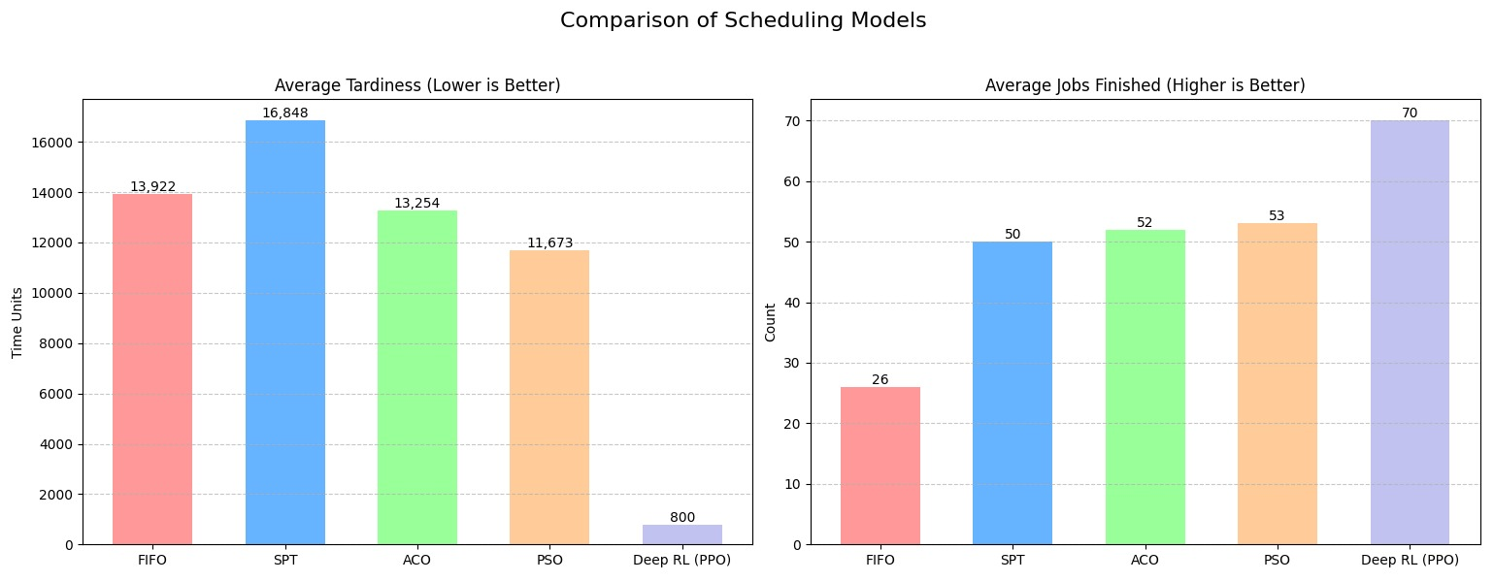
Figure 4: Average Tardiness and Jobs Completed with 15 Machines

4.3 Experiment 3: 50 Jobs with 7 Machines
The final experiment simulated a crisis environment with critical resource constraints, operating with only 7 machines and a low arrival rate (lambda approx. 25). The target was 50 jobs within 1000-time units. As expected, the severe bottleneck caused throughput to drop below 50% for all models. FIFO again performed poorest, finishing only 12 jobs with a tardiness of 7,254, confirming its inability to handle high-pressure scenarios.
The most striking result in this extreme experiment was the efficiency of the meta-heuristics. SPT and ACO tied for the highest throughput, completing 23 jobs, but incurred tardiness values of 6,085 and 5,592 respectively. PSO, completing 22 jobs, managed to reduce the average tardiness to just 3,274. This represents a roughly 46% reduction in tardiness compared to SPT. These finding highlights that in highly constrained environments, the cost of a suboptimal decision is magnified; PSO's ability to incorporate slack time into its decision weights allowed it to effectively "triage" the workload, focusing resources on achievable deadlines rather than simply processing the shortest tasks.
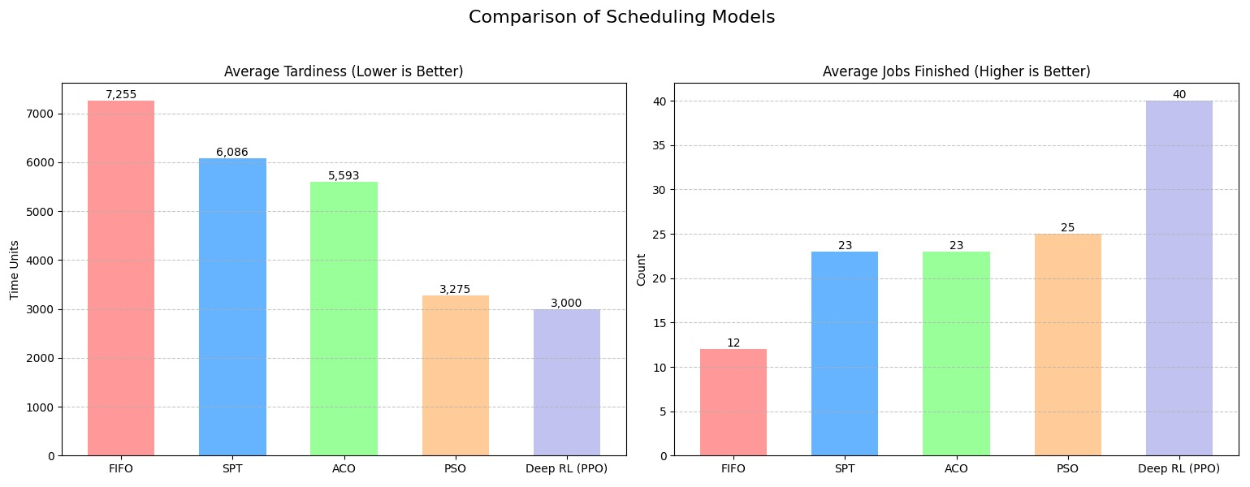
Figure 5: Average Tardiness and Jobs Completed with 7 Machines

4.4 Discussions
Analyzing the results across all three experiments reveals a clear hierarchy of performance. FIFO proved unsuitable for dynamic Job Shop Scheduling, consistently failing to deliver acceptable throughput or timeliness. SPT functioned as a reliable engine for throughput, consistently delivering the highest volume of work, but often at the cost of high tardiness due to its inability to see due dates. ACO generally matched SPT in throughput but struggled to consistently outperform it in tardiness, likely due to stochastic noise affecting pheromone stability. Finally, PSO demonstrated the highest level of adaptability. By dynamically weighting processing time against slack time, it consistently minimized Total Weighted Tardiness across all levels of resource constraint, making it the preferred choice for environments where customer deadlines are the primary key performance indicator.

5. Conclusion and Future Work

5.1 Conclusion
This project has successfully designed, implemented, and evaluated a comprehensive framework for solving the dynamic Job Shop Scheduling Problem (JSSP), benchmarking traditional baseline heuristics and meta-heuristics against an advanced Deep Reinforcement Learning (DRL) agent. The comparative analysis across distinct experimental scenarios confirms that while conventional methods struggle with the volatility of modern manufacturing, the DRL approach offers a superior and more robust solution.
The experimental results clearly demonstrated the limitations of static rules. First-In-First-Out (FIFO) consistently failed to deliver viable schedules, resulting in the highest tardiness and lowest throughput. While the Shortest Processing Time (SPT) heuristic proved effective for maximizing raw throughput, it critically failed to address due-date constraints, leading to unacceptable tardiness levels due to the starvation of long-duration jobs. Although meta-heuristic approaches, particularly Particle Swarm Optimization (PSO) and Ant Colony Optimization (ACO), offered significant improvements over baselines, they remained limited by their requirement for iterative re-optimization during real-time disruptions.
The most significant finding of this study is the superior performance of the Proximal Policy Optimization (PPO) agent. The DRL agent consistently outperformed all other models in minimizing Total Weighted Tardiness while maintaining high throughput. Unlike static or iterative methods, the DRL agent demonstrated operational resilience by learning to dynamically interpret complex state signals—including machine breakdown status and queue urgency. This capability allowed it to navigate extreme bottleneck scenarios more effectively than even the optimized PSO algorithm, validating the hypothesis that a learned, non-linear policy provides the most effective solution for stochastic industrial environments.

5.2 Future Work
While the current framework provides a resilient foundation for autonomous scheduling, the transition to full-scale industrial deployment offers several avenues for further research:
- Multi-Agent Reinforcement Learning (MARL): To address the "curse of dimensionality" in larger factory layouts, future research should explore decentralized MARL. In this architecture, each machine acts as an autonomous agent, communicating local queue states to neighbors to achieve emergent global optimization without the computational overhead of a centralized controller.
- Energy-Aware "Green" Scheduling: As sustainability becomes a core industrial KPI, the reward function could be expanded to include energy consumption. The agent would learn to manage machine power states—such as triggering "Standby" or "Sleep" modes during low-demand periods—to balance energy savings against the "warm-up" time required for production resumption.
- Integration with Digital Twins: Moving beyond stochastic modeling, the framework could be integrated with a Digital Twin architecture. By receiving real-time IoT sensor data regarding tool wear and mechanical vibrations, the DRL agent could transition from reactive scheduling to proactive, predictive maintenance scheduling, rerouting critical jobs before a projected failure occurs.
- Multi-Objective Pareto Optimization: Future work could implement Multi-Objective Reinforcement Learning (MORL) to generate a Pareto front of solutions. This would allow production managers to select between different policy profiles—such as a "High-Throughput" mode for peak seasons or a "Cost-Optimization" mode for standard operations—providing human-in-the-loop flexibility for strategic decision-making.
By addressing these areas, the current project can be evolved into a comprehensive, self-optimizing production management system capable of driving the next generation of intelligent, sustainable manufacturing facilities.

References
[1] R. S. Sutton and A. G. Barto, Reinforcement Learning: An Introduction, 2nd ed. Cambridge, MA, USA: MIT Press, 2018.
[2] L. Wang, S. Wan, J. Wang, and J. Cheng, "Deep Reinforcement Learning for Dynamic Scheduling in Smart Manufacturing," IEEE Transactions on Industrial Informatics, vol. 17, no. 6, pp. 4220-4230, June 2021.
[3] J. Schulman, F. Wolski, P. Dhariwal, A. Radford, and O. Klimov, "Proximal Policy Optimization Algorithms," arXiv preprint arXiv:1707.06347, 2017.
[4] H. Zhang, G. Xu, and G. Zhou, "A Deep Reinforcement Learning Based Approach for Rescheduling Problems in Job Shop," Computers & Industrial Engineering, vol. 138, p. 106116, 2019.
[5] M. Dorigo and T. Stützle, Ant Colony Optimization, MIT Press, 2004.
[6] T. Kaihara, N. Fujii, and D. Kokuryo, "A Proposal of Self-Organized Job Shop Scheduling with Deep Reinforcement Learning," Procedia CIRP, vol. 72, pp. 1070-1075, 2018.
[7] da Cunha, A. S. C., & de Madureira, J. A. P. P., "A Multi-Agent Reinforcement Learning Approach to the Dynamic Job Shop Scheduling Problem," Sustainability, vol. 15, no. 10, p. 8262, 2023.
[8] R. S. Sutton and A. G. Barto, Reinforcement Learning: An Introduction, 2nd ed. Cambridge, MA, USA: MIT Press, 2018.
[9] S. S. Panwalkar and W. Iskander, "A Survey of Scheduling Rules," Operations Research, vol. 25, no. 1, pp. 45-61, 1977.
[10] M. Dorigo and T. Stützle, Ant Colony Optimization, MIT Press, 2004.
[11] S. Liu, C. Lu, and J. Li, "An Improved Particle Swarm Optimization for the Job Shop Scheduling Problem," Applied Soft Computing, vol. 11, no. 8, pp. 4760-4769, 2011.
[12] J. Schulman, F. Wolski, P. Dhariwal, A. Radford, and O. Klimov, "Proximal Policy Optimization Algorithms," arXiv preprint arXiv:1707.06347, 2017.
[13] Wang et al., "Comparative Study of Reinforcement Learning Performance Based on PPO and DQN Algorithms," ResearchGate, 2024.
[14] T. Akiba, S. Sano, T. Yanase, T. Ohta, and M. Koyama, "Optuna: A Next-generation Hyperparameter Optimization Framework," in Proc. 25th ACM SIGKDD Int. Conf. Knowl. Discovery Data Mining, 2019, pp. 2623–2631.
[15] H. Zhang, G. Xu, and G. Zhou, "A Deep Reinforcement Learning Based Approach for Rescheduling Problems in Job Shop," Computers & Industrial Engineering, vol. 138, p. 106116, 2019.
[16] Holthaus, O., & Rajendran, C. (1997). Efficient dispatching rules for scheduling in a real-time production system. International Journal of Production Economics, 48(1), 87–105.
[17] Pinedo, M. (2016). Scheduling: Theory, Algorithms, and Systems. Springer.
[18] Vieira, G., Herrmann, J., & Lin, E. (2003). Rescheduling manufacturing systems: A framework of strategies, policies, and methods. Journal of Scheduling, 6(1), 39–62.
[19] Jain, A. S., & Meeran, S. (1999). Deterministic job-shop scheduling: Past, present, and future. European Journal of Operational Research, 113(2), 390–434.
[20] Ouelhadj, D., & Petrovic, S. (2009). A survey of dynamic scheduling in manufacturing systems. Journal of Scheduling, 12(4), 417–431.
[21] Blackstone, J. H., Phillips, D. T., & Hogg, G. L. (1982). A state-of-the-art survey of dispatching rules for manufacturing job shop operations. International Journal of Production Research, 20(1), 27–45.
[22] Bonomi, A., & Laface, P. (2014). Real-time scheduling in flexible manufacturing systems under machine breakdown. Robotics and Computer-Integrated Manufacturing, 30(6), 558–565.

